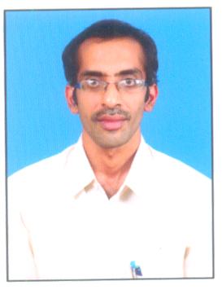 | TEACHING STAFF TEMPLATE  EMPLOYER NAME  P DEVENDRAN
FATHER NAME | P PAYANI
DATE OF BIRTH | 21-8-1978
GENDER | MALE
CATEGORY | BC-A
EDUCATIONAL QUALIFICATION | M.Sc, M.Phil
PERCENTAGE OF MARKS IN PG | 69.09%
HIGHEST QUALIFICATIONS | M.Phil
TOTAL SERVICE AS A CONTRACT LECTURER | 20 YEARS
SERVICE DETAILS | FROM | TO
- PVKN GOVT.COLLEGE, CHITTOOR | 26-8-2002 | 31-03-2003
- Smt.NPS GOVT.COLLEGE(W), CHITTOOR | 7-8-2003 | 31-03-2013
- PVKN GOVT.COLLEGE, CHITTOOR | 26-8-2013 | 5-8-2018
- Smt.NPS GOVT.COLLEGE(W), CHITTOOR | 6-8-2018 | Till date
CONTACT ADDRESS | P.DEVENDRAN,  24-160/4,  LAKSHMI NAGAR COLONY,  CHITTOOR.
PHONE | 8328593747, 8978597104
Mail Id | devendran21stat@gmail.com
SIGNATURE

PAPERS PUBLISHED

Name of the Lecturer | Topic | Place | Year and month
P Devendran | Study Of Design Of Regression Test Case Optimization Techniques | ZENITH International Journal Of Multidisciplinary Research | March 2019
 | Study on the geometry achievement of the male and female students | ZENITH International Journal Of Multidisciplinary Research | September 2020
 | Study the linear relationship between the intelligence and geometry achievement of the students | ZENITH International Journal Of Multidisciplinary Research | September 2021

MEMBER IN COLLEGE COMMITTEES

- Scholarship Committee
- Time Table Committee
- Admissions Committee
- Academic Co-ordination Committee
- Alumini Association Committee
- Bio-metric Authentication Committee
- Solar Energy Committee
- Media Committee

